My coding assignment was one of a creative challenge. I’ve always been hugely interested in the creation side of music, as well as the theory side. In my own time, I listen to everything from jazz, to techno, to funk soul music. I believe that music is the best thing in the world. That’s why I wanted to make something similar to Skin on Skin’s “Way Ur Touchin Me”. I chose this creative challenge because, as said, I’m very interested in music, but I know little to nothing about the theory behind it. In week 4, we started on TunePad, starting the coding journey for music. At the time, I found it really interesting, but wasn’t thinking about what my digital project was going to be. The project overall took me a total of 8 weeks, working at least 30 minutes most days of the week, sometimes less, sometimes more, but I did underestimate the amount of work it was.

As weeks passed, I’d talk to my classmates about their ideas, and I realised that being not 100% interested in the subject of coding, my prototype had to be about something I was interested in. That being dance music. Through each week I’d read the weekly readings, and find myself becoming more and more interested. In Berry’s reading he spoke about the nature of code, and how software can be manipulated in many ways. He states “...the interpretation of code as a textual artefact… It forms the first part of the development process which is written on the computer and details the functions and processes that a computer is to follow…”(Berry, 2011) Furthermore, each class enabled me to learn more and more, eventually speaking about our prototype pitch. At that moment, I knew I wanted to make a song with the platform TunePad. As I did research into the platform, I realised it was quite rudimentary, and therefore, I realised the end product may not have been as good and as similar as I would have liked. At that point I also started researching Sonic Pi as a possible additive to the end of my project, however, I underestimated how much work it was just on TunePad so I didn’t end up switching.

To start with my project I utilised sources from tutorials on the software, as well as youtube tutorials, but also completed projects that I drew inspiration from such as the House Beat Project. Through this, it allowed me to start my project, whilst also reminding of Manaris’ “Making Music With Computers Reading”, where he states “everything we experience through our senses can be described by numbers, in some way or another, and then it can be turned into music.” (Manaris, 2017). As said, I’ve always been very interested in music, but this way of creating music was completely new to me, so there was also a steep learning curve, especially the piano chords. I had to listen by ear, continuously switching between tabs trying to get the right sounding chord. Similar to what Horn and colleagues said in the Python Programming book, stating “Code gives us an elegant language to think about musical ideas, and music gives us a context within which code makes sense and is immediately useful.” (Horn, et al, 2022).

In Petzold’s book about code, he describes code in a more musical tone stating; “A code lets you communicate. Sometimes codes are secret, but most codes are not. Indeed, most codes must be well understood because they’re the basis of human communication.” (Petzold, 2023) I utilised 6 different layers of sounds to create my similar sounding project. 4 drums layers, all utilising different notes, using the playNote command, and then two separate Keyboard layers, and to make it easier, I used the “Instant Chords” tool. I started my code with the intro of the drums, focusing on the 8 repetitive 808 bass hits, and then having to figure out the pattern of which the song continues. After this painful process, I expanded it to be equal to 68 beats, setting the guideline for my other components. Thus, setting a guideline for the rest of my components. This project with coding music really opened my eyes to how difficult music production is, even without incorporating coding. Similar to what Müller said, “A musical score is rarely played mechanically. Musicians may shape the flow of the music by varying the tempo, dynamics, and articulation, thus resulting in a personal interpretation of the given musical score.” (Müller, 2021), the choice of my coding project to be a creative one, had its tough points, but also was very expandable, depending on the amount of effort I put into it. As I finished my project, I took on some peer evaluation from a class mate of mine, Oliver. We went back and forth as we both were doing musical projects, showing the differences between each project, and how our genres differed from the code we were making. He was doing a jazz swing project, where he only used one cell, where as my project, I used 6. Similar to Oliver, my friend Jayden was also doing a music project, focusing on a similar style to Oliver's. Yet, jayden utilised several cells, with all varying instruments, which honestly impressed me a ton. Through these peer reviews, I was able to focus on the smaller bits of my project, and being able to refine them for a better result. 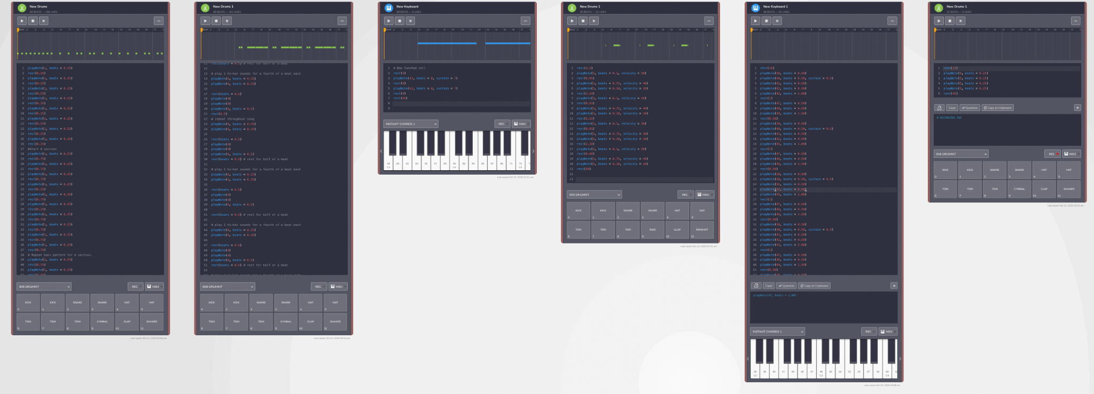

Overall, this coding project was a unique way for me to further connect with one of my biggest passions - music. Starting with little to no experience on the music theory side, the project was a steep climb, as I’d spend hours trying to figure out the code that wouldn’t even last for 10 seconds. It was a continuous project that I’d have to work on every day. To finish, although not as long as I wanted it to be, I’m very proud of how it was finished. I believed I created a really similar song, to the best of my abilities, whilst also adding my own twists to it.

MANARIS, B. (2017). MAKING MUSIC WITH COMPUTERS : creative programming in python. (1st edition). CRC Press.

Petzold, C. (2023). Code : the hidden language of computer hardware and software (Second edition.). Microsoft Press.

Horn, M. S., West, M., & Roberts, C. (2022). Introduction to Digital Music with Python Programming: Learning Music with Code (1st ed.). Routledge. https://doi.org/10.4324/9781003033240

Müller, M. (2021). Fundamentals of music processing : using Python and Jupyter notebooks (Second edition.). Springer.

Berry, D. M. (2011). The philosophy of software: Code and mediation in the digital age. Palgrave Macmillan.